**Plugging into the Future: An Exploration of Electricity Consumption Patterns**

1. Introduction

Consumption pattern of energy shows the percentage use of different sources (solar energy, wind energy, geothermal energy, biogas, and tidal power). The consumption pattern of energy changes over time. Commercial sources of energy: Commercial energy makes up about 65% of the total energy consumed in India. During 2021-22, the per capita electricity consumption in India is 945.98 kilowatt-hour (Kwh). According to the official data the total installed capacity of the country stood at 4,12,212 MW, as on Feb. 2023.

2. EMPTHY MAP

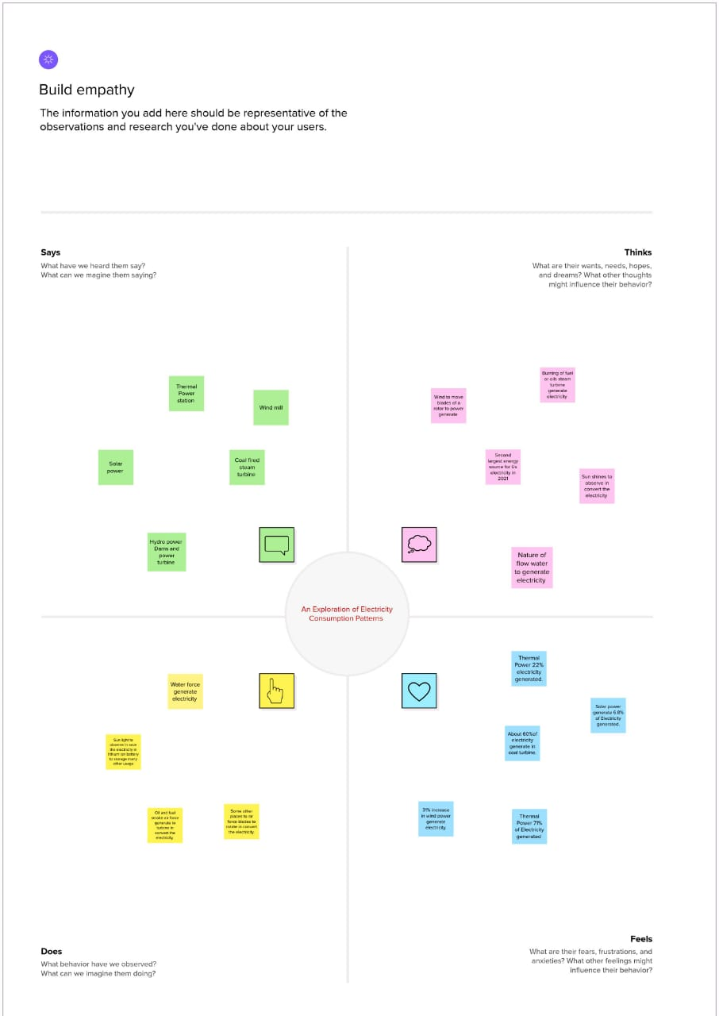

3. Brainstrome and idea prioritization :

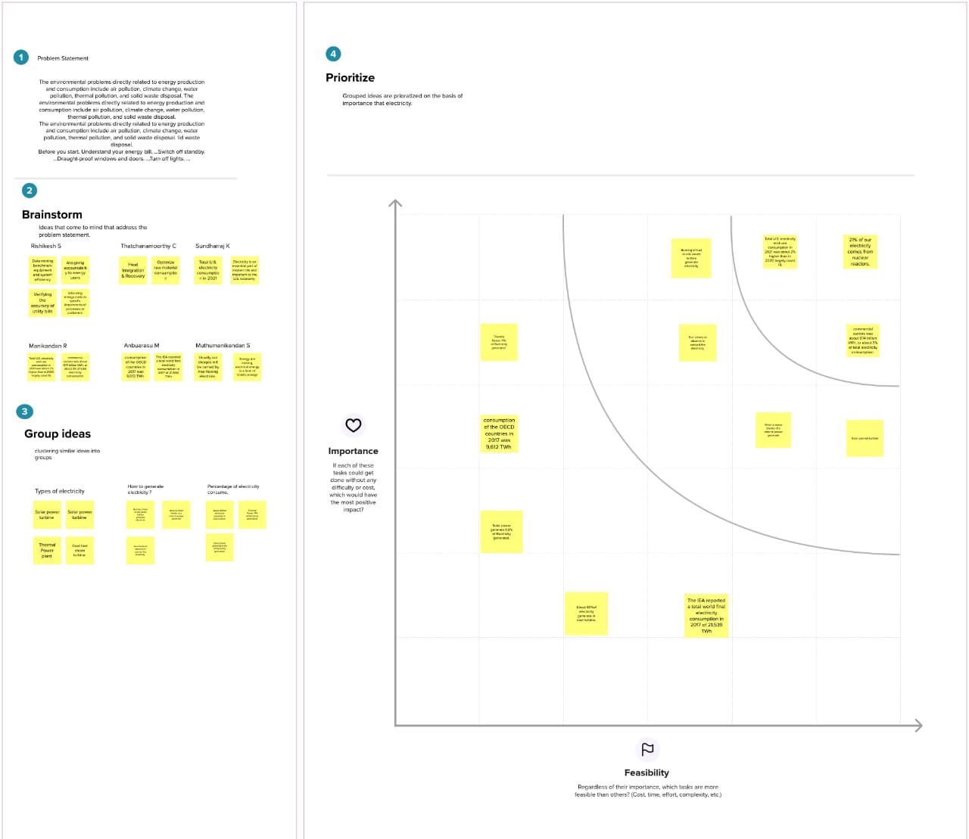

4 . Tableau Public :

Usage by Region

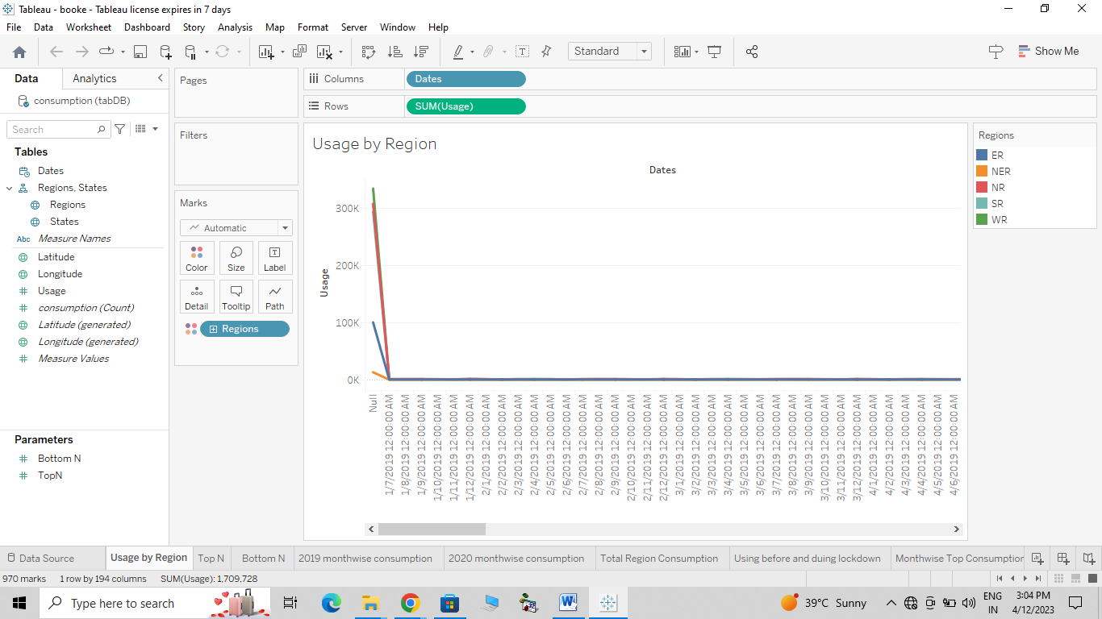

Top N Consumption :

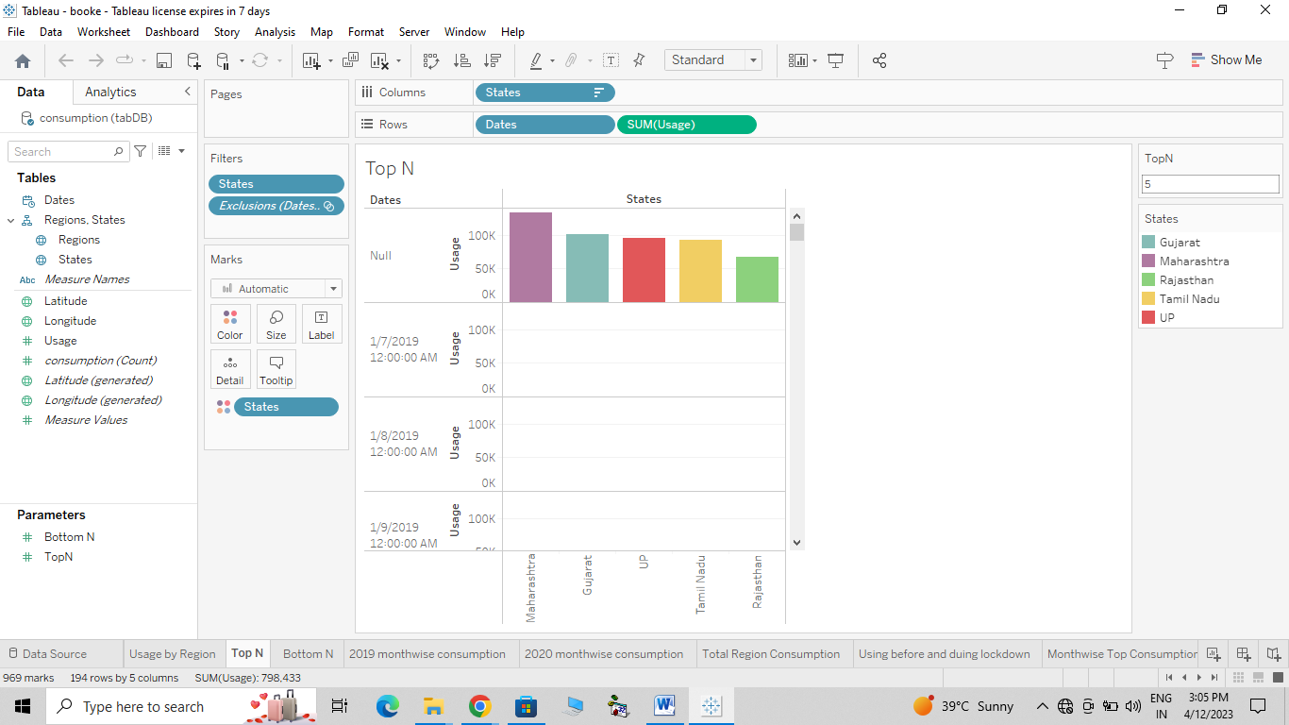

Bottom N Consumption

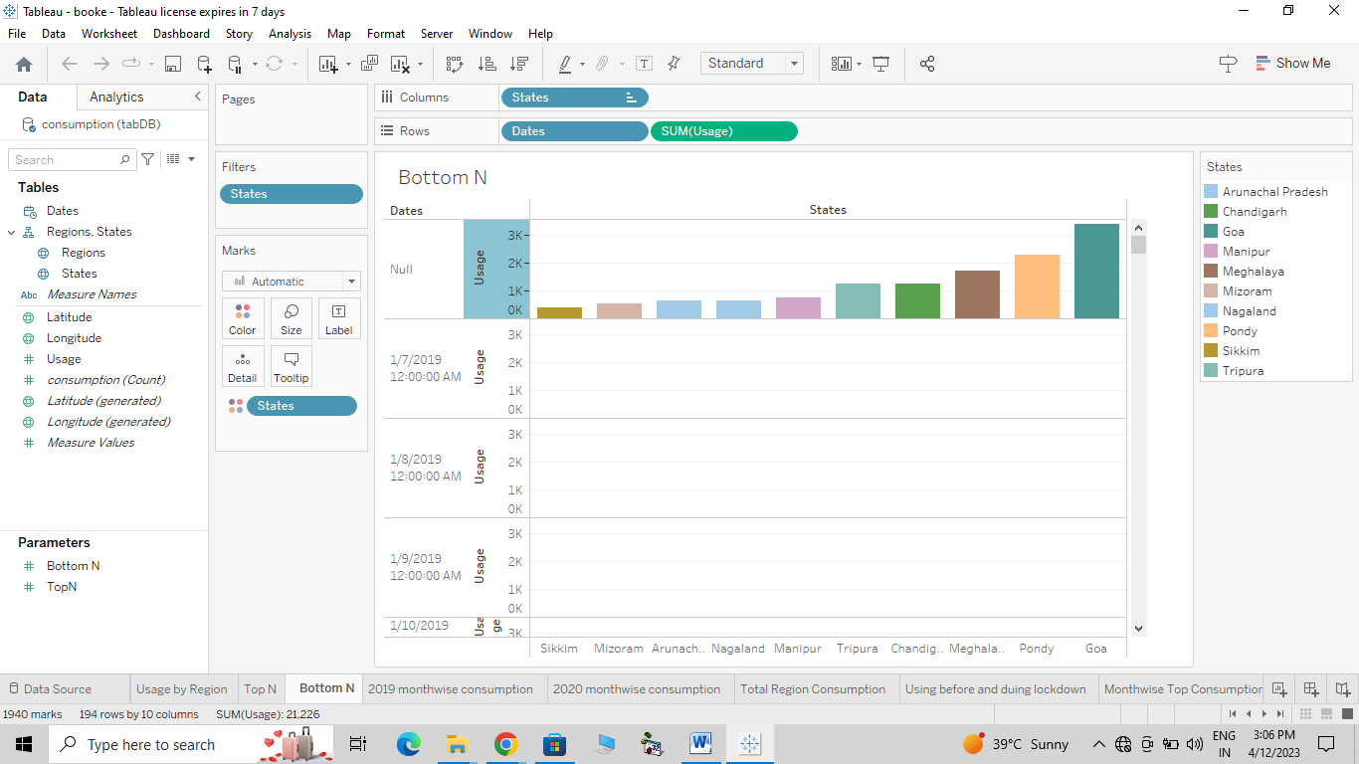

Total Region Consumption :

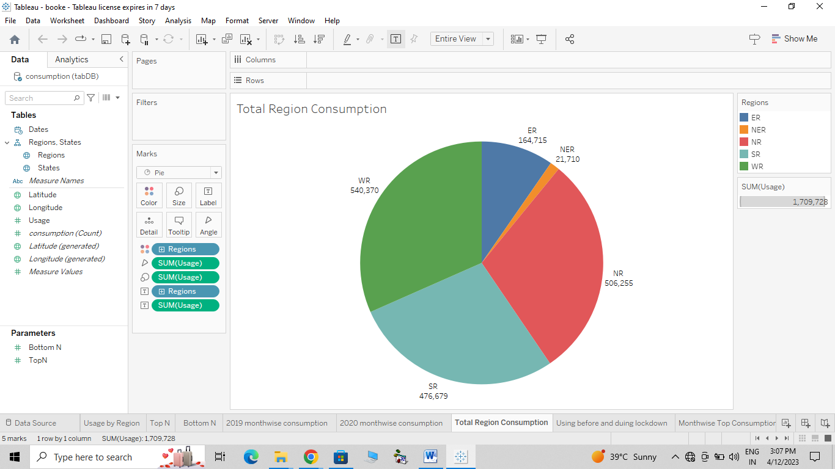

MonthWise Top Consumption

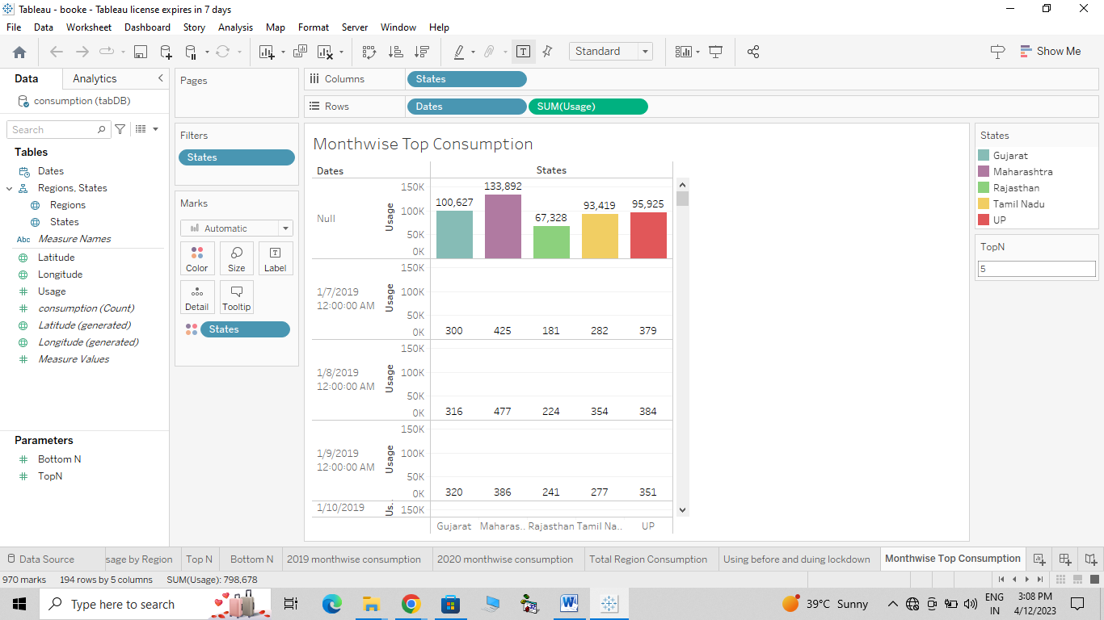

Region Wise Consumption :

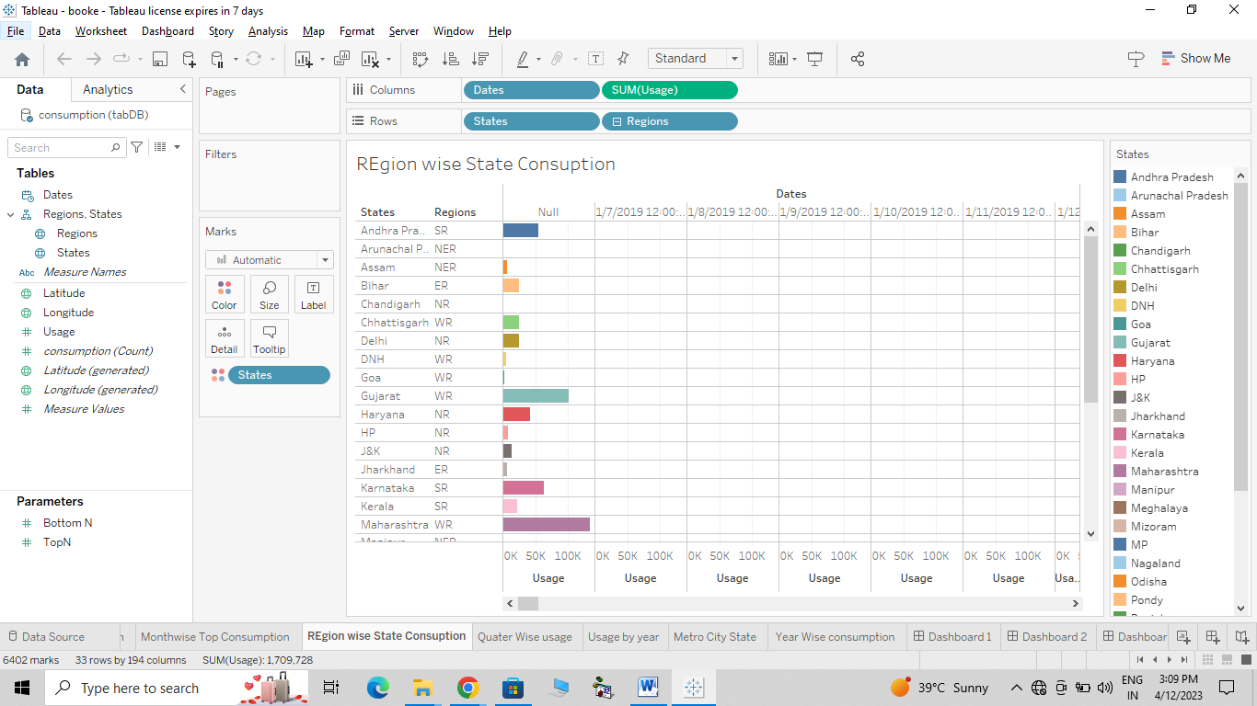

Usage by Year Consumption :

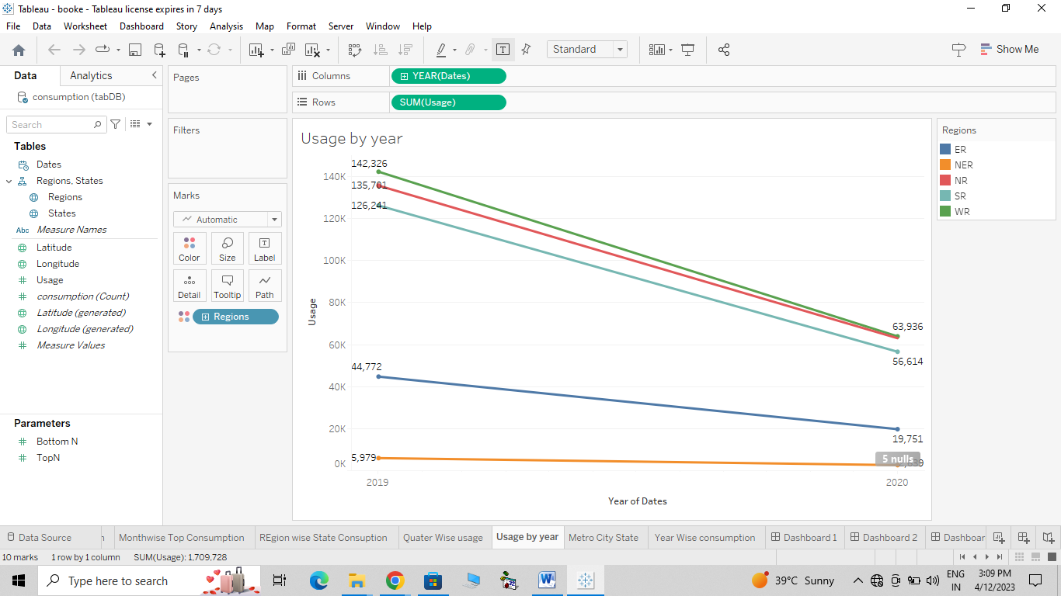

Metro city Consumption

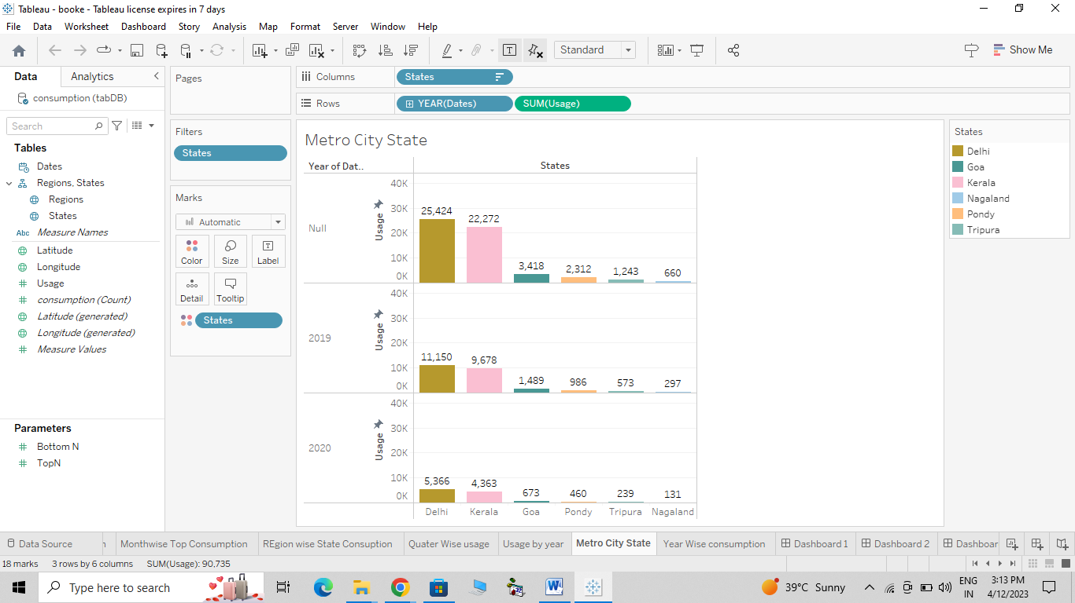

Year Wise Consumption :

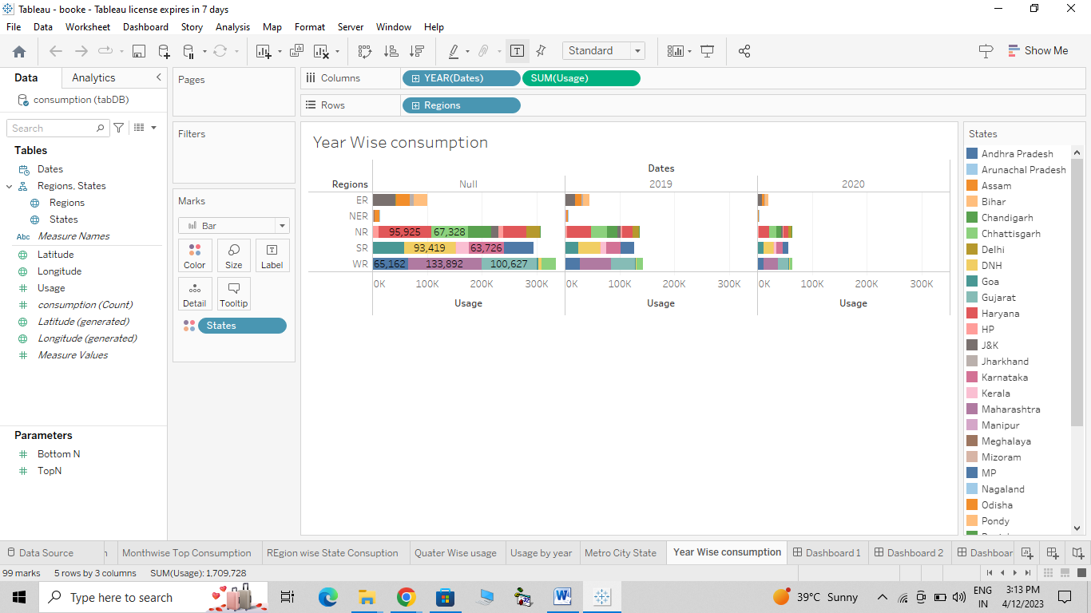

Dassboard

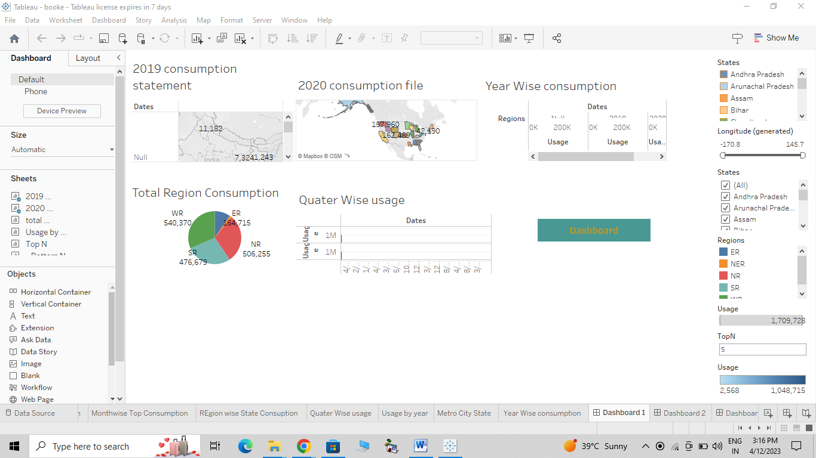

Story of Electricity Connsumption Patterns:

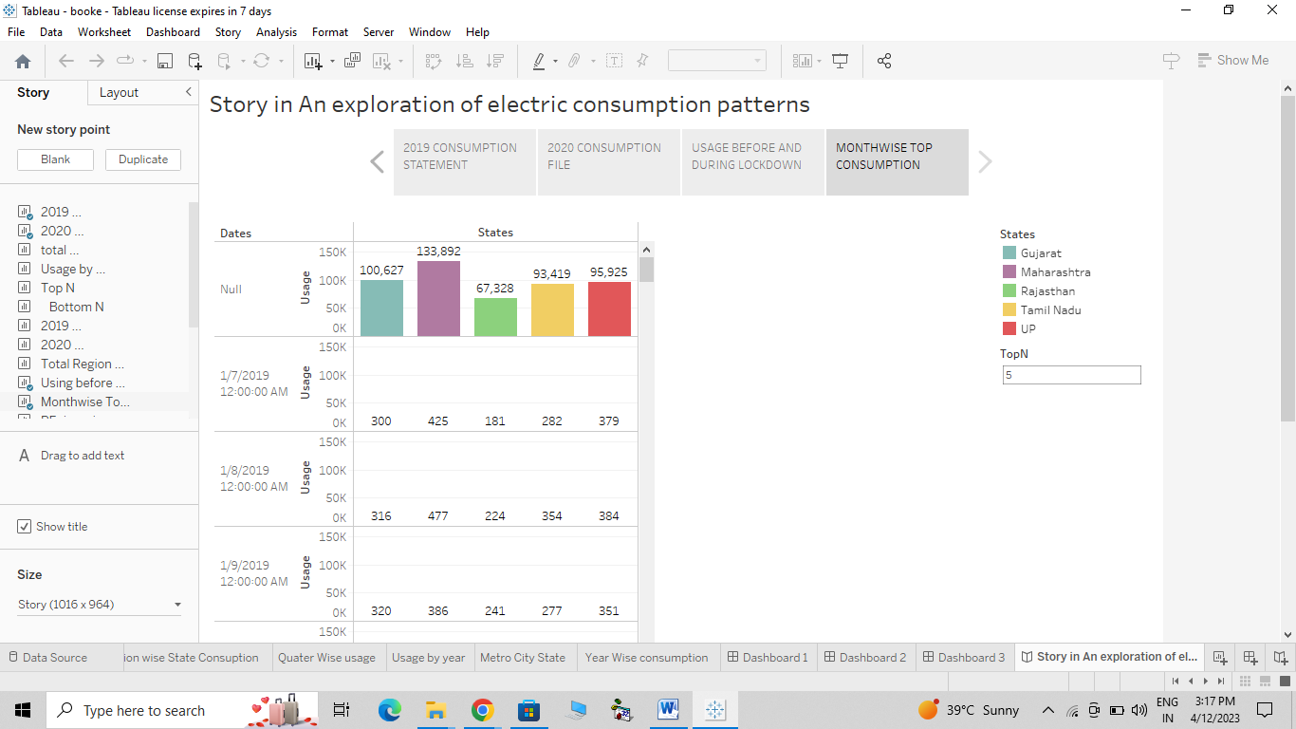

Tableau Public :

Dassboard 1 :

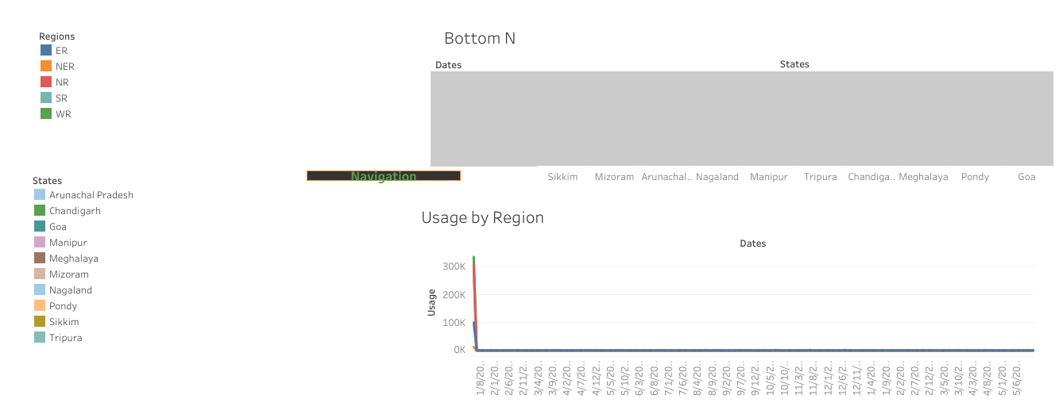

Dassboard 2 :



Story in An Exploration of electric consumption patterns

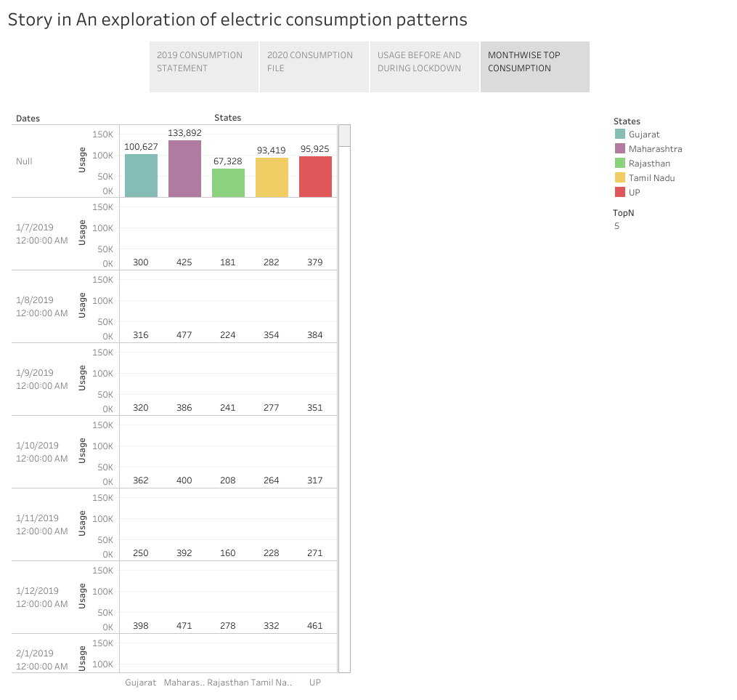

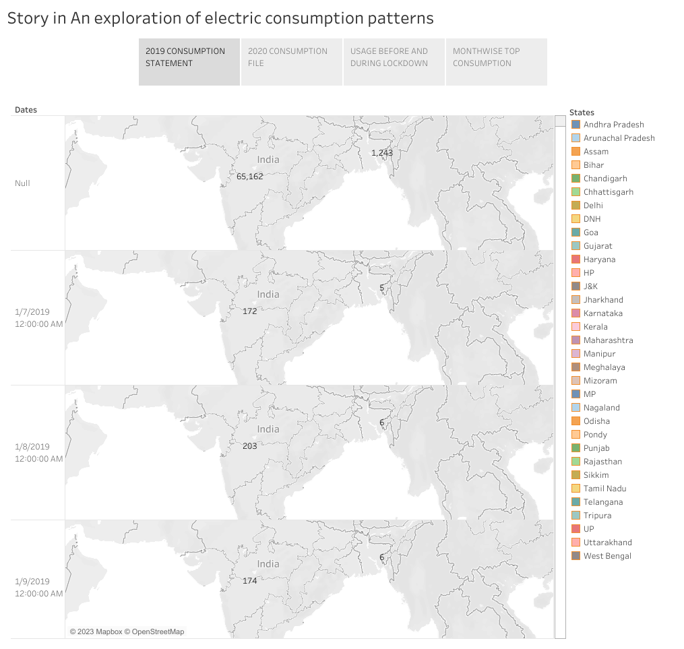

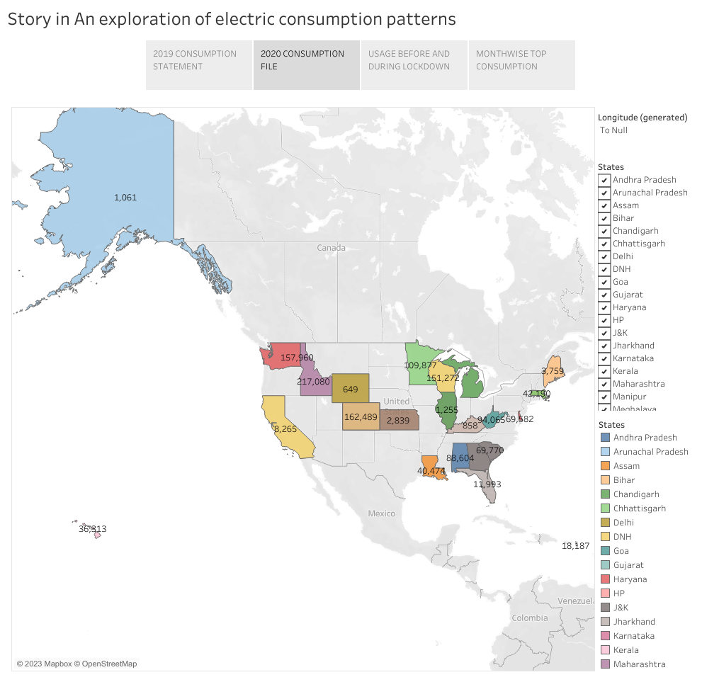

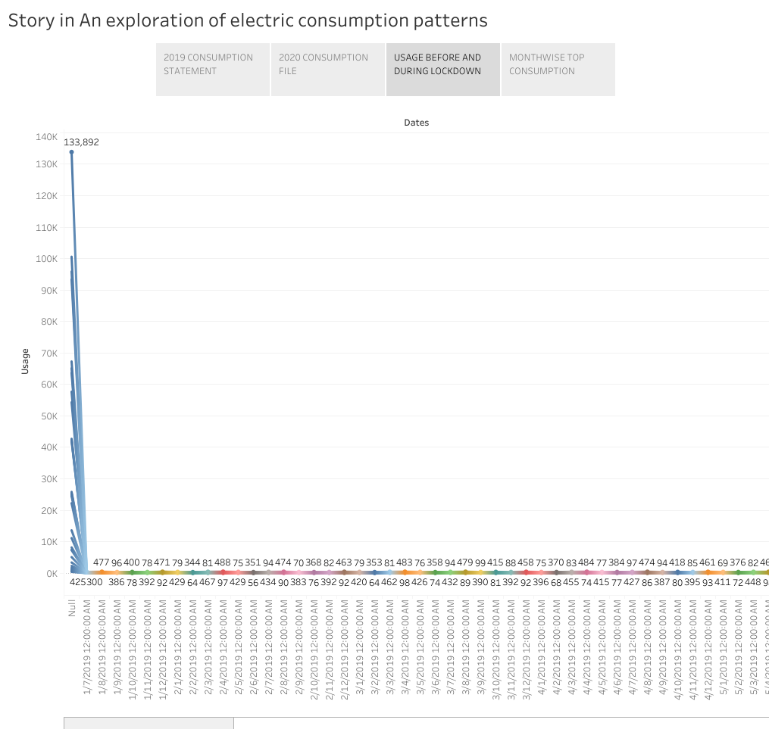

Web Intregration

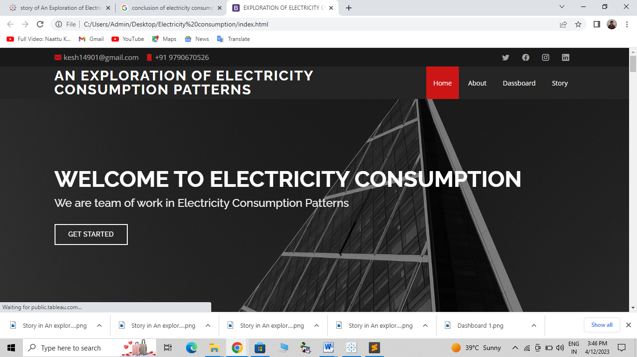

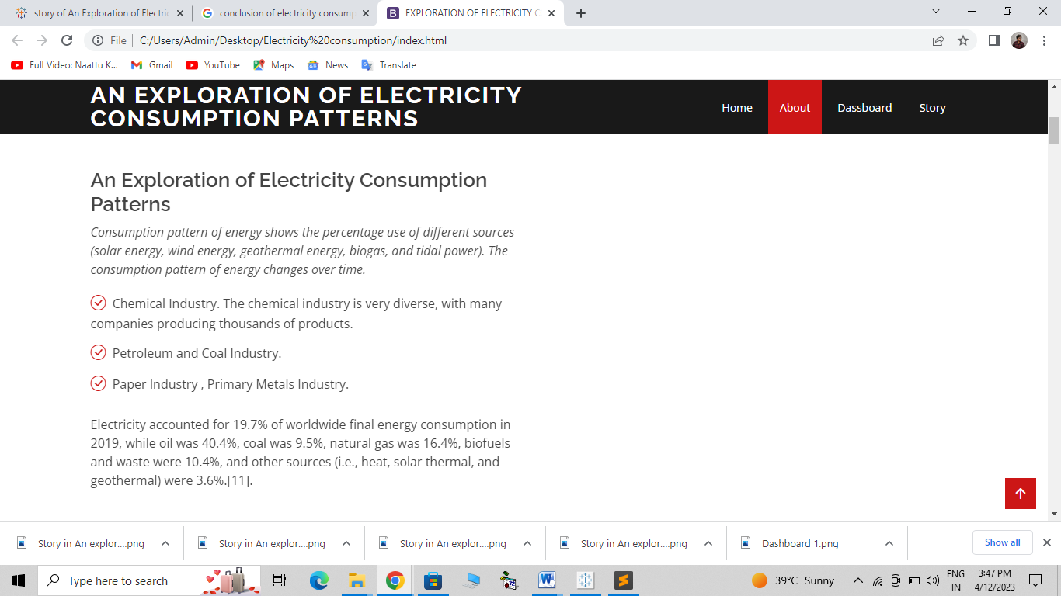

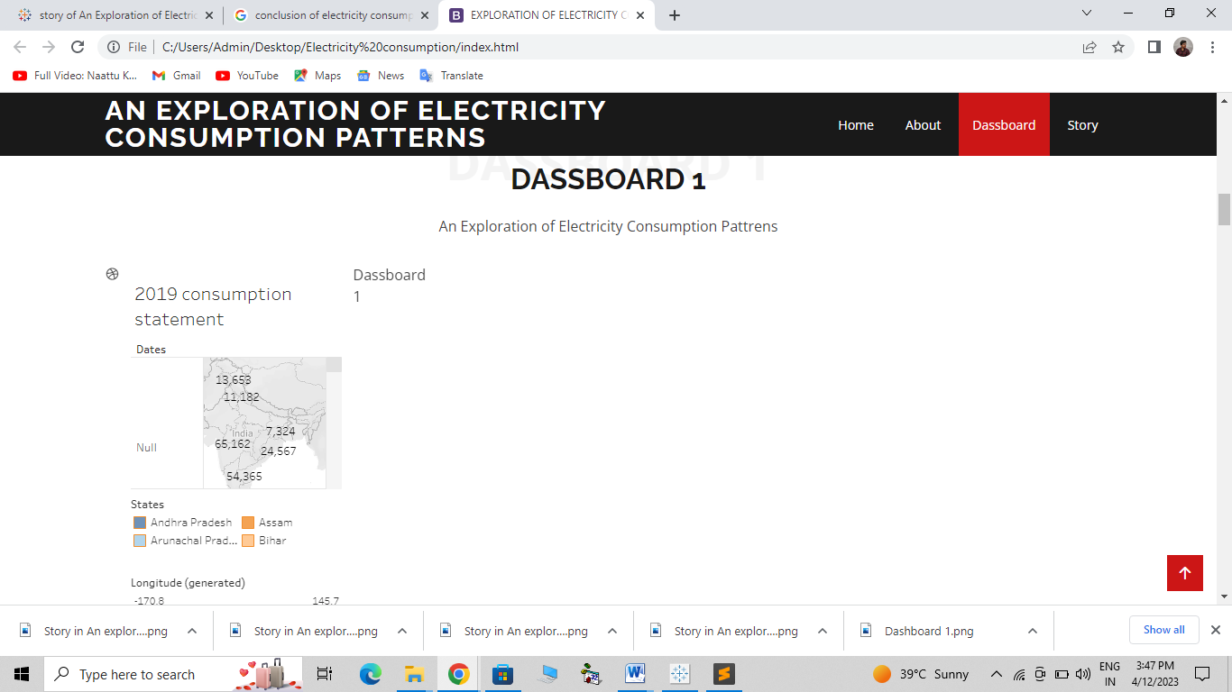

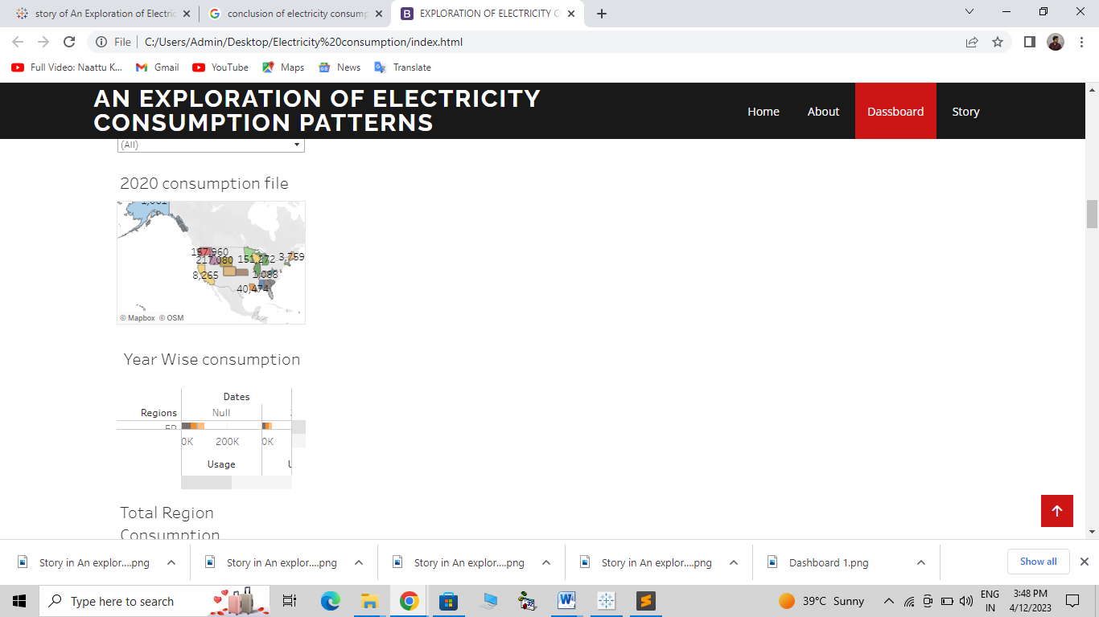

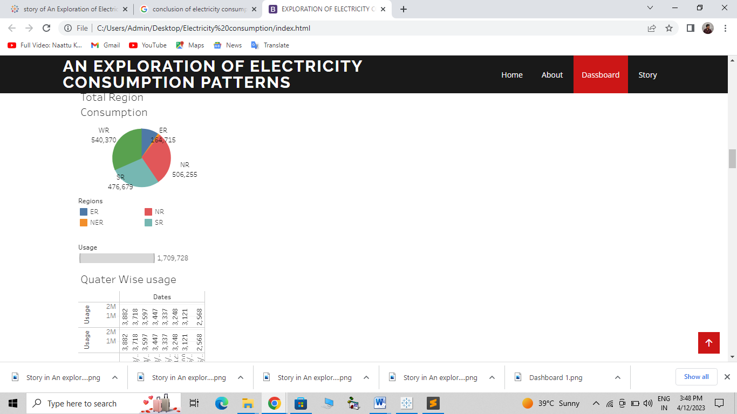

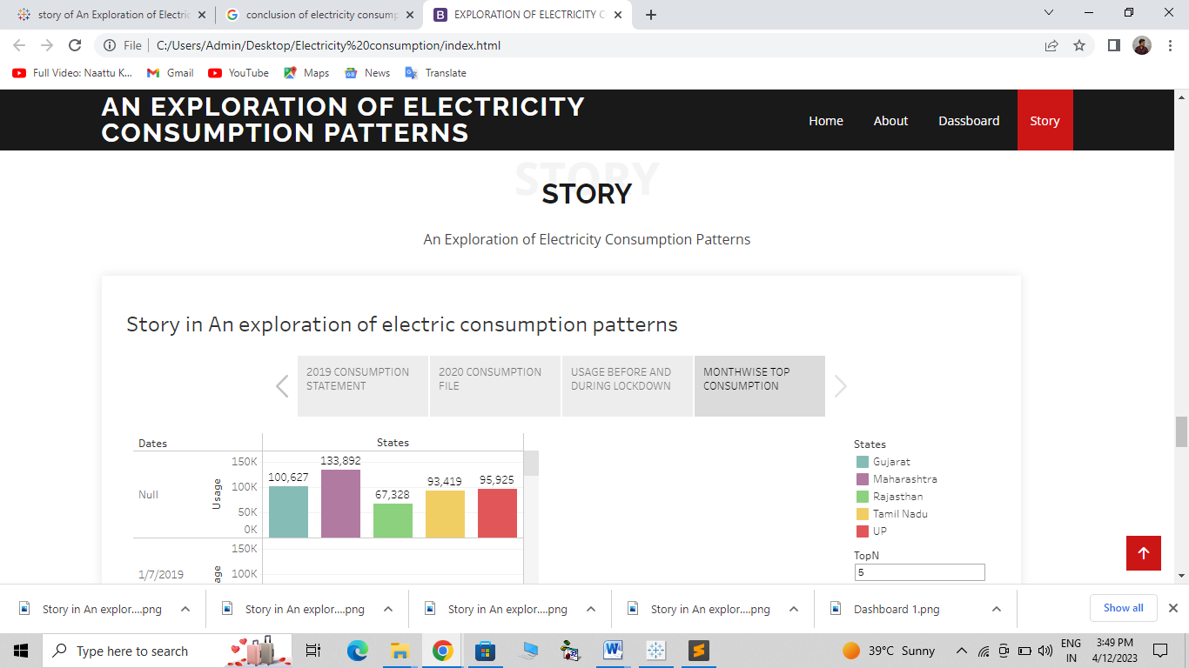

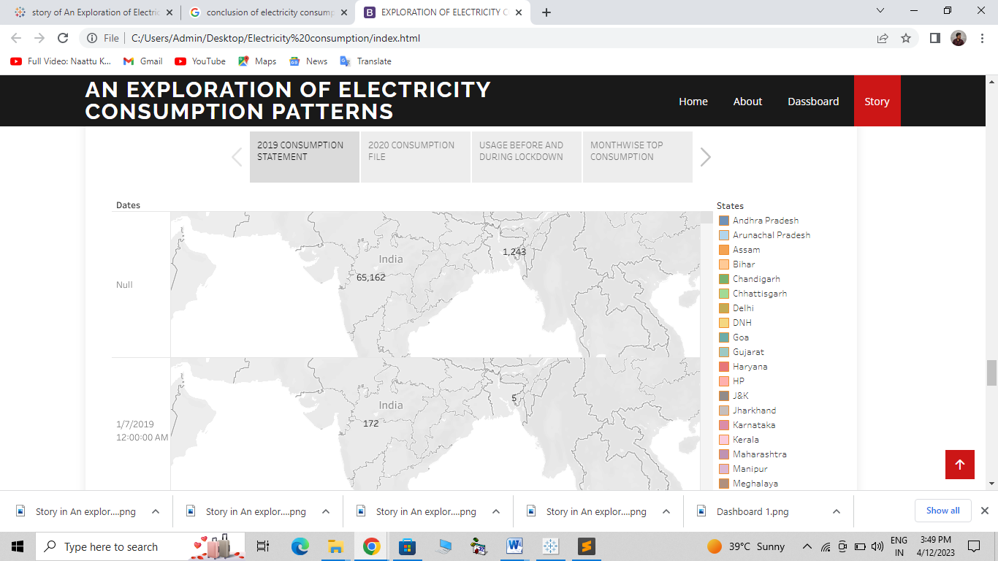

**Conclusion** :

Current through a given area of a conductor is the net charge that passes per unit time through the conductor. To keep up a gradual current, we must have a circuit within which an electrical phenomenon occurs from lower to higher mechanical energy.

Energy conservation, in addition to lowering energy costs, can benefit the environment in a variety of ways.

For starters, **energy conservation can protect the environment by reducing resource consumption and carbon dioxide emissions**. Following that, energy conservation can reduce the need for new power plants.

Electric energy consumption is **the form of energy consumption that uses electrical energy**. Electric energy consumption is the actual energy demand made on existing electricity supply for transportation, residential, industrial, commercial, and other miscellaneous purposes.

Annual electricity consumption per capita serves as **an important measure of a country's electric power development**. Generally speaking, electricity consumption grows faster when the industrialization process develops quickly and goes down rapidly when industrialization is completed or near completion.

**Coding :**

**<!**DOCTYPE html>

<html lang="en">

<head>

<meta charset="utf-8">

<meta content="width=device-width, initial-scale=1.0" name="viewport">

<title>EXPLORATION OF ELECTRICITY CONSUMPTION</title>

<meta content="" name="description">

<meta content="" name="keywords">

<!-- Favicons -->

<link href="assets/img/favicon.png" rel="icon">

<link href="assets/img/apple-touch-icon.png" rel="apple-touch-icon">

<!-- Google Fonts -->

<link href="https://fonts.googleapis.com/css?family=Open+Sans:300,300i,400,400i,600,600i,700,700i|Raleway:300,300i,400,400i,500,500i,600,600i,700,700i|Poppins:300,300i,400,400i,500,500i,600,600i,700,700i" rel="stylesheet">

<!-- Vendor CSS Files -->

<link href="assets/vendor/aos/aos.css" rel="stylesheet">

<link href="assets/vendor/bootstrap/css/bootstrap.min.css" rel="stylesheet">

**<link href="assets/vendor/bootstrap-icons/bootstrap-icons.css" rel="stylesheet">**

**<link href="assets/vendor/boxicons/css/boxicons.min.css" rel="stylesheet">**

<link href="assets/vendor/glightbox/css/glightbox.min.css" rel="stylesheet">

<link href="assets/vendor/swiper/swiper-bundle.min.css" rel="stylesheet">

<!-- Template Main CSS File -->

<link href="assets/css/style.css" rel="stylesheet">

<!-- =======================================================

* Template Name: EXPLORATION OF ELECTRICITY CONSUMPTION

* Updated: Mar 10 2023 with Bootstrap v5.2.3

* Template URL: https://bootstrapmade.com/day-multipurpose-html-template-for-free/

* Author: BootstrapMade.com

* License: https://bootstrapmade.com/license/

======================================================== -->

</head>

<body>

<!-- ======= Top Bar ======= -->

<section id="topbar" class="d-flex align-items-center">

<div class="container d-flex justify-content-center justify-content-md-between">

<div class="contact-info d-flex align-items-center">

<i class="bi bi-envelope-fill"></i><a href="mailto:contact@example.com">kesh14901@gmail.com</a>

<i class="bi bi-phone-fill phone-icon"></i> +91 9790670526

</div>

**<div class="social-links d-none d-md-block">**

**<a href="#" class="twitter"><i class="bi bi-twitter"></i></a>**

**<a href="#" class="facebook"><i class="bi bi-facebook"></i></a>**

**<a href="#" class="instagram"><i class="bi bi-instagram"></i></a>**

**<a href="#" class="linkedin"><i class="bi bi-linkedin"></i></i></a>**

**</div>**

**</div>**

**</section>**

**<!-- ======= Header ======= -->**

**<header id="header" class="d-flex align-items-center">**

**<div class="container d-flex align-items-center justify-**content-between">

<h1 class="logo"><a href="index.html">An Exploration of Electricity Consumption Patterns</a></h1>

<!-- Uncomment below if you prefer to use an image logo -->

<!-- <a href="index.html" class="logo"><img src="assets/img/logo.png" alt="" class="img-fluid"></a>-->

<nav id="navbar" class="navbar">

<ul>

<li><a class="nav-link scrollto active" href="#hero">Home</a></li>

<li><a class="nav-link scrollto" href="#about">About</a></li>

<li><a class="nav-link scrollto" href="#services">Dassboard</a></li>

<li><a class="nav-link scrollto" href="#team">Story</a></li>

</ul>

<i class="bi bi-list mobile-nav-toggle"></i>

</nav><!-- .navbar -->

</div>

</header><!-- End Header -->

<!-- ======= Hero Section ======= -->

<section id="hero" class="d-flex align-items-center">

<div class="container position-relative" data-aos="fade-up" data-aos-delay="500">

<h1>Welcome to ELectricity Consumption</h1>

<h2>We are team of work in Electricity Consumption Patterns</h2>

<a href="#about" class="btn-get-started scrollto">Get Started</a>

</div>

</section><!-- End Hero -->

<main id="main">

<!-- ======= About Section ======= -->

<section id="about" class="about">

<div class="container">

<div class="row">

<div class="col-lg-6 order-1 order-lg-2" data-aos="fade-left">

</div>

<div class="col-lg-6 pt-4 pt-lg-0 order-2 order-lg-1 content" data-aos="fade-right">

<h3>An Exploration of Electricity Consumption Patterns</h3>

<p class="fst-italic">

Consumption pattern of energy shows the percentage use of different sources (solar energy, wind energy, geothermal energy, biogas, and tidal power). The consumption pattern of energy changes over time.

</p>

<ul>

<li><i class="bi bi-check-circle"></i> Chemical Industry. The chemical industry is very diverse, with many companies producing thousands of products. </li>

<li><i class="bi bi-check-circle"></i> Petroleum and Coal Industry.</li>

<li><i class="bi bi-check-circle"></i> Paper Industry , Primary Metals Industry.</li>

</ul>

<p>

Electricity accounted for 19.7% of worldwide final energy consumption in 2019, while oil was 40.4%, coal was 9.5%, natural gas was 16.4%, biofuels and waste were 10.4%, and other sources (i.e., heat, solar thermal, and geothermal) were 3.6%.[11].

</p>

</div>

</div>

</div>

</section><!-- End About Section -->

<!-- ======= Why Us Section ======= -->

<section id="why-us" class="why-us">

<div class="container">

<div class="row">

<div class="col-lg-4" data-aos="fade-up">

<div class="box">

<span>01</span>

<h4></h4>

<p>Ulamco laboris nisi ut aliquip ex ea commodo consequat. Et consectetur ducimus vero placeat</p>

</div>

</div>

<div class="col-lg-4 mt-4 mt-lg-0" data-aos="fade-up" data-aos-delay="300">

<div class="box">

<span>03</span>

<h4> Ad ad velit qui</h4>

<p>Molestiae officiis omnis illo asperiores. Aut doloribus vitae sunt debitis quo vel nam quis</p>

</div>

</div>

</div>

</div>

</section><!-- End Why Us Section -->

<!-- ======= Clients Section ======= -->

<section id="clients" class="clients">

<div class="container" data-aos="zoom-in">

<div class="row d-flex align-items-center">

<div class="col-lg-2 col-md-4 col-6">

<img src="assets/img/clients/client-1.png" class="img-fluid" alt="">

</div>

<div class="col-lg-2 col-md-4 col-6">

<img src="assets/img/clients/client-2.png" class="img-fluid" alt="">

</div>

<div class="col-lg-2 col-md-4 col-6">

<img src="assets/img/clients/client-3.png" class="img-fluid" alt="">

</div>

<div class="col-lg-2 col-md-4 col-6">

<img src="assets/img/clients/client-4.png" class="img-fluid" alt="">

</div>

<div class="col-lg-2 col-md-4 col-6">

<img src="assets/img/clients/client-5.png" class="img-fluid" alt="">

</div>

<div class="col-lg-2 col-md-4 col-6">

<img src="assets/img/clients/client-6.png" class="img-fluid" alt="">

</div>

</div>

</div>

</section><!-- End Clients Section -->

<!-- ======= Services Section ======= -->

<section id="services" class="services">

<div class="container">

<div class="section-title">

<span>Dassboard 1</span>

<h2>Dassboard 1</h2>

<p>An Exploration of Electricity Consumption Pattrens</p>

</div>

<div class="row">

<div class="col-lg-4 col-md-6 d-flex align-items-stretch" data-aos="fade-up">

<div class="icon"><i class="bx bxl-dribbble"></i></div>

<h4><a href=""><div class='tableauPlaceholder' id='viz1681224679603' style='position: relative'><noscript><a href='#'><img alt='Dashboard 1 ' src='https:&#47;&#47;public.tableau.com&#47;static&#47;images&#47;bo&#47;booke_16809280492610&#47;Dashboard1&#47;1_rss.png' style='border: none' /></a></noscript><object class='tableauViz' style='display:none;'><param name='host_url' value='https%3A%2F%2Fpublic.tableau.com%2F' /> <param name='embed_code_version' value='3' /> <param name='site_root' value='' /><param name='name' value='booke_16809280492610&#47;Dashboard1' /><param name='tabs' value='no' /><param name='toolbar' value='yes' /><param name='static_image' value='https:&#47;&#47;public.tableau.com&#47;static&#47;images&#47;bo&#47;booke_16809280492610&#47;Dashboard1&#47;1.png' /> <param name='animate_transition' value='yes' /><param name='display_static_image' value='yes' /><param name='display_spinner' value='yes' /><param name='display_overlay' value='yes' /><param name='display_count' value='yes' /><param name='language' value='en-US' /></object></div> <script type='text/javascript'> var divElement = document.getElementById('viz1681224679603'); var vizElement = divElement.getElementsByTagName('object')[0]; if ( divElement.offsetWidth > 800 ) { vizElement.style.width='100%';vizElement.style.height=(divElement.offsetWidth*0.75)+'px';} else if ( divElement.offsetWidth > 500 ) { vizElement.style.width='100%';vizElement.style.height=(divElement.offsetWidth*0.75)+'px';} else { vizElement.style.width='100%';vizElement.style.height='1627px';} var scriptElement = document.createElement('script'); scriptElement.src = 'https://public.tableau.com/javascripts/api/viz_v1.js'; vizElement.parentNode.insertBefore(scriptElement, vizElement); </script></a></h4>

<p>Dassboard 1</p>

</div>

</div>

<div class="col-lg-4 col-md-6 d-flex align-items-stretch mt-4 mt-md-0" data-aos="fade-up" data-aos-delay="150">

<div class="icon-box">

<div class="icon"><i class="bx bx-file"></i></div>

<h4><a href="">Sed ut perspiciatis</a></h4>

<p>Duis aute irure dolor in reprehenderit in voluptate velit esse cillum dolore</p>

</div>

</div>

<div class="col-lg-4 col-md-6 d-flex align-items-stretch mt-4 mt-lg-0" data-aos="fade-up" data-aos-delay="300">

<div class="icon-box">

<div class="icon"><i class="bx bx-tachometer"></i></div>

<h4><a href="">Magni Dolores</a></h4>

<p>Excepteur sint occaecat cupidatat non proident, sunt in culpa qui officia</p>

</div>

</div>

<div class="col-lg-4 col-md-6 d-flex align-items-stretch mt-4" data-aos="fade-up" data-aos-delay="450">

<div class="icon-box">

<div class="icon"><i class="bx bx-world"></i></div>

<h4><a href="">Nemo Enim</a></h4>

<p>At vero eos et accusamus et iusto odio dignissimos ducimus qui blanditiis</p>

</div>

</div>

<div class="col-lg-4 col-md-6 d-flex align-items-stretch mt-4" data-aos="fade-up" data-aos-delay="600">

<div class="icon-box">

<div class="icon"><i class="bx bx-slideshow"></i></div>

<h4><a href="">Dele cardo</a></h4>

<p>Quis consequatur saepe eligendi voluptatem consequatur dolor consequuntur</p>

</div>

</div>

<div class="col-lg-4 col-md-6 d-flex align-items-stretch mt-4" data-aos="fade-up" data-aos-delay="750">

<div class="icon-box">

<div class="icon"><i class="bx bx-arch"></i></div>

<h4><a href="">Divera don</a></h4>

<p>Modi nostrum vel laborum. Porro fugit error sit minus sapiente sit aspernatur</p>

</div>

</div>

</div>

</div>

</section><!-- End Services Section -->

<!-- ======= Cta Section ======= -->

<section id="cta" class="cta">

<div class="container" data-aos="zoom-in">

<div class="text-center">

<h3>Call To Action</h3>

<p> Duis aute irure dolor in reprehenderit in voluptate velit esse cillum dolore eu fugiat nulla pariatur. Excepteur sint occaecat cupidatat non proident, sunt in culpa qui officia deserunt mollit anim id est laborum.</p>

<a class="cta-btn" href="#">Call To Action</a>

</div>

</div>

</section><!-- End Cta Section -->

**<!-- ======= Portfolio Section ======= -->**

**<section id="portfolio" class="portfolio">**

**<div class="container">**

**<div class="section-title">**

**<span>Dassboard 2</span>**

**<h2>Dassboard 2</h2>**

**<p>An Exploration of Electricity Consumption Patterns</p>**

**</div>**

**</div>**

**<div class="row portfolio-container" data-aos="fade-up" data-aos-delay="150">**

**<div class="col-lg-4 col-md-6 portfolio-item filter-app">**

<div class="portfolio-info">

**<h4><div class='tableauPlaceholder' id='viz1681225060916' style='position: relative'><noscript><a href='#'><img alt='Dashboard 3 ' src='https:&#47;&#47;public.tableau.com&#47;static&#47;images&#47;bo&#47;bookg&#47;Dashboard3&#47;1_rss.png' style='border: none' /></a></noscript><object class='tableauViz' style='display:none;'><param name='host_url' value='https%3A%2F%2Fpublic.tableau.com%2F' /> <param name='embed_code_version' value='3' /> <param name='site_root' value='' /><param name='name' value='bookg&#47;Dashboard3' /><param name='tabs' value='no' /><param name='toolbar' value='yes' /><param name='static_image' value='https:&#47;&#47;public.tableau.com&#47;static&#47;images&#47;bo&#47;bookg&#47;Dashboard3&#47;1.png' /> <param name='animate_transition' value='yes' /><param name='display_static_image' value='yes' /><param name='display_spinner' value='yes' /><param name='display_overlay' value='yes' /><param name='display_count' value='yes' /><param name='language' value='en-US' /></object></div> <script type='text/javascript'> var divElement = document.getElementById('viz1681225060916'); var vizElement = divElement.getElementsByTagName('object')[0]; if ( divElement.offsetWidth > 800 ) { vizElement.style.width='100%';vizElement.style.height=(divElement.offsetWidth*0.75)+'px';} else if ( divElement.offsetWidth > 500 ) { vizElement.style.width='100%';vizElement.style.height=(divElement.offsetWidth*0.75)+'px';} else { vizElement.style.width='100%';vizElement.style.height='827px';} var scriptElement = document.createElement('script'); scriptElement.src = 'https://public.tableau.com/javascripts/api/viz_v1.js'; vizElement.parentNode.insertBefore(scriptElement, vizElement); </script></h4>**

**<p>App</p>**

**<a href="assets/img/portfolio/portfolio-1.jpg" data-gallery="portfolioGallery" class="portfolio-lightbox preview-link" title="App 1"><i class="bx bx-plus"></i></a>**

**<a href="portfolio-details.html" class="details-link" title="More Details"><i class="bx bx-link"></i></a>**

**</div>**

**</section><!-- End Pricing Section -->**

**<!-- ======= Team Section ======= -->**

**<section id="team" class="team">**

**<div class="container">**

**<div class="section-title">**

**<span>Story</span>**

**<h2>story</h2>**

**<p>An Exploration of Electricity Consumption Patterns</p>**

**</div>**

**<div class="row">**

**<div class="col-lg-4 col-md-6 d-flex align-items-stretch" data-aos="zoom-in">**

**<div class="member">**

**<h4><div class='tableauPlaceholder' id='viz1681225553193' style='position: relative'><noscript><a href='#'><img alt='Story in An exploration of electric consumption patterns ' src='https:&#47;&#47;public.tableau.com&#47;static&#47;images&#47;st&#47;storyofAnExplorationofElectricityConsumptionPatterns&#47;StoryinAnexplorationofelectricconsumptionpatterns&#47;1_rss.png' style='border: none' /></a></noscript><object class='tableauViz' style='display:none;'><param name='host_url' value='https%3A%2F%2Fpublic.tableau.com%2F' /> <param name='embed_code_version' value='3' /> <param name='site_root' value='' /><param name='name' value='storyofAnExplorationofElectricityConsumptionPatterns&#47;StoryinAnexplorationofelectricconsumptionpatterns' /><param name='tabs' value='no' /><param name='toolbar' value='yes' /><param name='static_image' value='https:&#47;&#47;public.tableau.com&#47;static&#47;images&#47;st&#47;storyofAnExplorationofElectricityConsumptionPatterns&#47;StoryinAnexplorationofelectricconsumptionpatterns&#47;1.png' /> <param name='animate_transition' value='yes' /><param name='display_static_image' value='yes' /><param name='display_spinner' value='yes' /><param name='display_overlay' value='yes' /><param name='display_count' value='yes' /><param name='language' value='en-US' /></object></div> <script type='text/javascript'> var divElement = document.getElementById('viz1681225553193'); var vizElement = divElement.getElementsByTagName('object')[0]; vizElement.style.width='1016px';vizElement.style.height='991px'; var scriptElement = document.createElement('script'); scriptElement.src = 'https://public.tableau.com/javascripts/api/viz_v1.js'; vizElement.parentNode.insertBefore(scriptElement, vizElement); </script></h4>**

**<span>Chief Executive Officer</span>**

**<p>**

**Magni qui quod omnis unde et eos fuga et exercitationem. Odio veritatis perspiciatis quaerat qui aut aut aut**

**</p>**

**<div class="social">**

**<a href=""><i class="bi bi-twitter"></i></a>**

**<a href=""><i class="bi bi-facebook"></i></a>**

**<a href=""><i class="bi bi-instagram"></i></a>**

**<a href=""><i class="bi bi-linkedin"></i></a>**

**</div>**

**</div>**

**</div>**

**<div class="social">**

**<a href=""><i class="bi bi-twitter"></i></a>**

**<a href=""><i class="bi bi-facebook"></i></a>**

**<a href=""><i class="bi bi-instagram"></i></a>**

**<a href=""><i class="bi bi-linkedin"></i></a>**

**</div>**

**</div>**

**</div>**

**<div class="social">**

**<a href=""><i class="bi bi-twitter"></i></a>**

**<a href=""><i class="bi bi-facebook"></i></a>**

**<a href=""><i class="bi bi-instagram"></i></a>**

**<a href=""><i class="bi bi-linkedin"></i></a>**

**</div>**

**</div>**

**</div>**

**</div>**

**</div>**

**</section><!-- End Team Section -->**

**<!-- ======= Contact Section ======= -->**

**<section id="contact" class="contact">**

**<div class="container">**

**<div class="section-title">**

**<span>Contact</span>**

**<h2>Contact</h2>**

**<p>Sit sint consectetur velit quisquam cupiditate impedit suscipit alias</p>**

**</div>**

**<div class="row" data-aos="fade-up">**

**<div class="col-lg-6">**

**<div class="info-box mb-4">**

**<i class="bx bx-map"></i>**

**<h3>Our Address</h3>**

**<p>A108 Adam Street, New York, NY 535022</p>**

**</div>**

**</div>**

**<div class="col-lg-3 col-md-6">**

**<div class="info-box mb-4">**

**<i class="bx bx-envelope"></i>**

**<h3>Email Us</h3>**

**<p>contact@example.com</p>**

**</div>**

**</div>**

**<div class="col-lg-3 col-md-6">**

**<div class="info-box mb-4">**

**<i class="bx bx-phone-call"></i>**

**<h3>Call Us</h3>**

**<p>+1 5589 55488 55</p>**

**</div>**

**</div>**

**</div>**

**<div class="row" data-aos="fade-up">**

**<div class="col-lg-6 ">**

**<iframe class="mb-4 mb-lg-0" src="https://www.google.com/maps/embed?pb=!1m14!1m8!1m3!1d12097.433213460943!2d-74.0062269!3d40.7101282!3m2!1i1024!2i768!4f13.1!3m3!1m2!1s0x0%3A0xb89d1fe6bc499443!2sDowntown+Conference+Center!5e0!3m2!1smk!2sbg!4v1539943755621" frameborder="0" style="border:0; width: 100%; height: 384px;" allowfullscreen></iframe>**

**</div>**

**<div class="col-lg-6">**

**<form action="forms/contact.php" method="post" role="form" class="php-email-form">**

**<div class="row">**

**<div class="col-md-6 form-group">**

**<input type="text" name="name" class="form-control" id="name" placeholder="Your Name" required>**

**</div>**

**<div class="col-md-6 form-group mt-3 mt-md-0">**

**<input type="email" class="form-control" name="email" id="email" placeholder="Your Email" required>**

**</div>**

**</div>**

**<div class="form-group mt-3">**

**<input type="text" class="form-control" name="subject" id="subject" placeholder="Subject" required>**

**</div>**

**<div class="form-group mt-3">**

**<textarea class="form-control" name="message" rows="5" placeholder="Message" required></textarea>**

**</div>**

**<div class="my-3">**

**<div class="loading">Loading</div>**

**<div class="error-message"></div>**

**<div class="sent-message">Your message has been sent. Thank you!</div>**

**</div>**

**<div class="text-center"><button type="submit">Send Message</button></div>**

**</form>**

**</div>**

**</div>**

**</div>**

**</section><!-- End Contact Section -->**

**</main><!-- End #main -->**

**<!-- ======= Footer ======= -->**

**<footer id="footer">**

**<div class="footer-top">**

**<div class="container">**

**<div class="row">**

**<div class="col-lg-4 col-md-6">**

**<div class="footer-info">**

**<h3>Day</h3>**

**<p>**

**A108 Adam Street <br>**

**NY 535022, USA<br><br>**

**<strong>Phone:</strong> +1 5589 55488 55<br>**

**<strong>Email:</strong> info@example.com<br>**

**</p>**

**<div class="social-links mt-3">**

**<a href="#" class="twitter"><i class="bx bxl-twitter"></i></a>**

**<a href="#" class="facebook"><i class="bx bxl-facebook"></i></a>**

**<a href="#" class="instagram"><i class="bx bxl-instagram"></i></a>**

**<a href="#" class="google-plus"><i class="bx bxl-skype"></i></a>**

**<a href="#" class="linkedin"><i class="bx bxl-linkedin"></i></a>**

**</div>**

**</div>**

**</div>**

**<div class="col-lg-2 col-md-6 footer-links">**

**<h4>Useful Links</h4>**

**<ul>**

**<li><i class="bx bx-chevron-right"></i> <a href="#">Home</a></li>**

**<li><i class="bx bx-chevron-right"></i> <a href="#">About us</a></li>**

**<li><i class="bx bx-chevron-right"></i> <a href="#">Services</a></li>**

**<li><i class="bx bx-chevron-right"></i> <a href="#">Terms of service</a></li>**

**<li><i class="bx bx-chevron-right"></i> <a href="#">Privacy policy</a></li>**

**</ul>**

**</div>**

**<div class="col-lg-2 col-md-6 footer-links">**

**<h4>Our Services</h4>**

**<ul>**

**<li><i class="bx bx-chevron-right"></i> <a href="#">Web Design</a></li>**

**<li><i class="bx bx-chevron-right"></i> <a href="#">Web Development</a></li>**

**<li><i class="bx bx-chevron-right"></i> <a href="#">Product Management</a></li>**

**<li><i class="bx bx-chevron-right"></i> <a href="#">Marketing</a></li>**

**<li><i class="bx bx-chevron-right"></i> <a href="#">Graphic Design</a></li>**

**</ul>**

**</div>**

**<div class="col-lg-4 col-md-6 footer-newsletter">**

**<h4>Our Newsletter</h4>**

**<p>Tamen quem nulla quae legam multos aute sint culpa legam noster magna</p>**

**<form action="" method="post">**

**<input type="email" name="email"><input type="submit" value="Subscribe">**

**</form>**

**</div>**

**</div>**

**</div>**

**</div>**

**<div class="container">**

**<div class="copyright">**

**&copy; Copyright <strong><span>Day</span></strong>. All Rights Reserved**

**</div>**

**<div class="credits">**

**<!-- All the links in the footer should remain intact. -->**

**<!-- You can delete the links only if you purchased the pro version. -->**

**<!-- Licensing information: https://bootstrapmade.com/license/ -->**

**<!-- Purchase the pro version with working PHP/AJAX contact form: https://bootstrapmade.com/day-multipurpose-html-template-for-free/ -->**

**Designed by <a href="https://bootstrapmade.com/">BootstrapMade</a>**

**</div>**

**</div>**

**</footer><!-- End Footer -->**

**<a href="#" class="back-to-top d-flex align-items-center justify-content-center"><i class="bi bi-arrow-up-short"></i></a>**

**<div id="preloader"></div>**

**<!-- Vendor JS Files -->**

**<script src="assets/vendor/aos/aos.js"></script>**

**<script src="assets/vendor/bootstrap/js/bootstrap.bundle.min.js"></script>**

**<script src="assets/vendor/glightbox/js/glightbox.min.js"></script>**

**<script src="assets/vendor/isotope-layout/isotope.pkgd.min.js"></script>**

**<script src="assets/vendor/swiper/swiper-bundle.min.js"></script>**

**<script src="assets/vendor/php-email-form/validate.js"></script>**

**<!-- Template Main JS File -->**

**<script src="assets/js/main.js"></script>**

**</body>**

**</html>**